# Group Report Weeks 10 – 12

Group name: Goku

Group Members: Aidan Willis, James Sadler

## Assigned Tasks

James: Risk Management

Aidan: User Acceptance Tests

## James

### Week 10

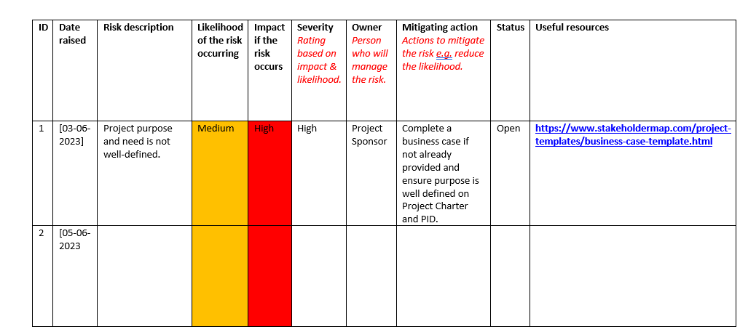

Started on making the risk analysis. This took some time to figure out what would be risky for the website

### Week 11

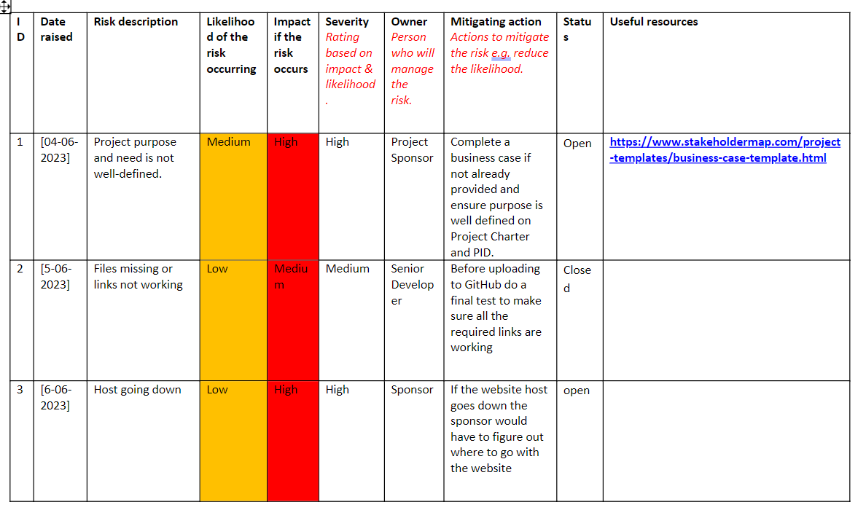

Continued working on the risk analysis and helped Aidan with the user acceptance testing, primarily with spelling

Week 12

Finished off the risk analysis, made sure it was all spell checked and grammatically correct.

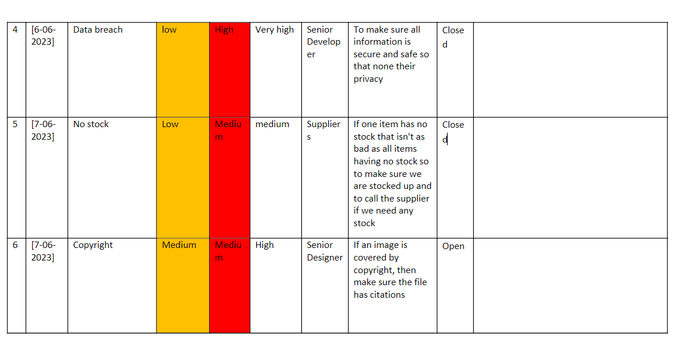

Aidan

### Week 10

This week I started on the user test did some work and asked James for help, but he was busy this week so will get help the next week

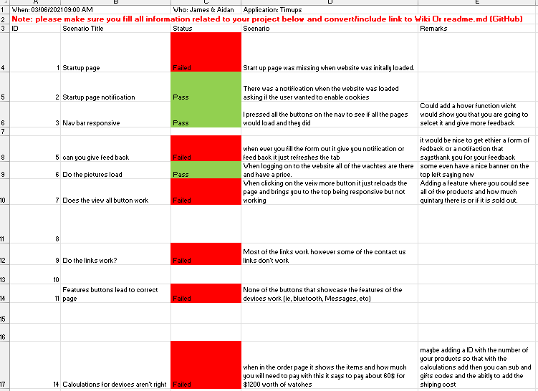

### Week 11

Finished the user test with the help of James needs to be spell check and then shipped off to git hub

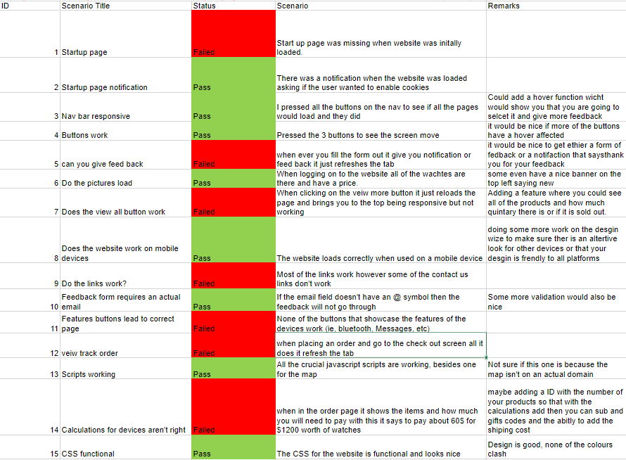

### Week 12

With this week it was all check and then sent to the git page

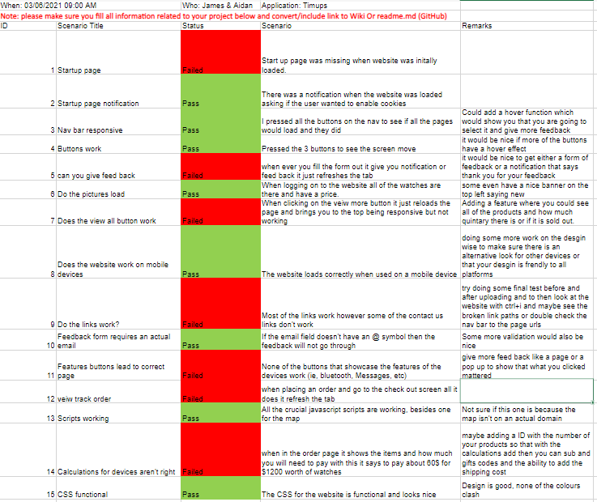

## Group Issues

### Issues we’ve come across

Deadlines and other assignments

### Issues dealt with and how we fixed them

We just put more time into the assignments and stressed a lot

### Challenges

Doing 3 assignments at once

Trying to make a schedule around James's job and Balance work and study

### Achievements

Getting a 2 and above 50% in the last two tests and getting the work done for this class and the struggle of the cyclone.